Assignment-4

|  |  |
| --- | --- |
| AssignmentDate | 17 november2022 |
| StudentName | M.Eashwar |
| StudentRollNumber | 421319104004 |
| MaximumMarks | 2Marks |

Question1:

DownloadthedatasetLink:

<https://drive.google.com/file/d/1Sjqx5H5R86tRp2YZKzzd4_iEfjChZ3ob/view?usp=sharing>

Question2:

ImportrequiredlibrarySolution:

importpandas as pdimport numpyas npfromkerasimportutils

importmatplotlib.pyplotaspltimportseabornassns

fromsklearn.model_selectionimporttrain_test_splitfrom sklearn.preprocessingimport LabelEncoderfromkeras.modelsimportModel

fromkeras.layersimportLSTM,Activation,Dense,Dropout,Input,Embeddingfromkeras.optimizersimportRMSprop

fromkeras.preprocessing.textimportTokenizerfrom keras.preprocessingimport sequencefromkeras.utilsimportto_categorical

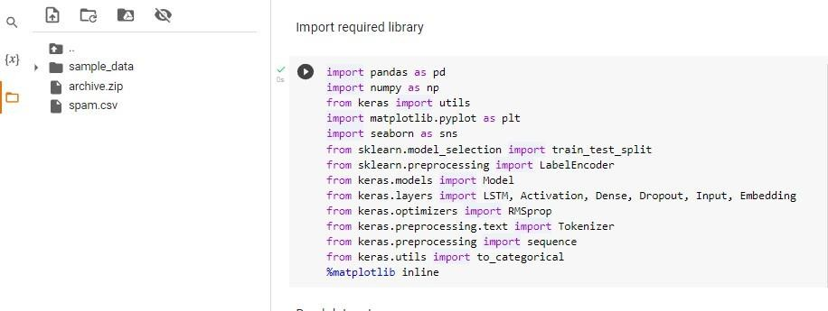

Question3:

Readdatasetanddopre-processingSolution:

Readdataset

# !unzip"/content/archive.zip"

df=pd.read_csv('spam.csv',delimiter=',',encoding='latin-1')df

Preprocessing

# df.drop(['Unnamed:2','Unnamed:3','Unnamed:4'],axis=1,inplace=True)df

sns.countplot(df.v1,palette='Set3')plt.xlabel('Label')

plt.title('Numberofhamandspammessages')

X = df.v2Y=df.v1

le=LabelEncoder()Y=le.fit_transform(Y)Y=Y.reshape(-1,1)

X_train,X_test,Y_train,Y_test= train_test_split(X,Y,test_size=0.15)max_words=1000

max_len=150

tok= Tokenizer(num_words=max_words)tok.fit_on_texts(X_train)

sequences=tok.texts_to_sequences(X_train)

sequences_matrix=utils.pad_sequences(sequences,maxlen=max_len)

sequences_matrix.shapesequences_matrix.ndim

sequences_matrix= np.reshape(sequences_matrix,(4736,150,1))sequences_matrix.ndim

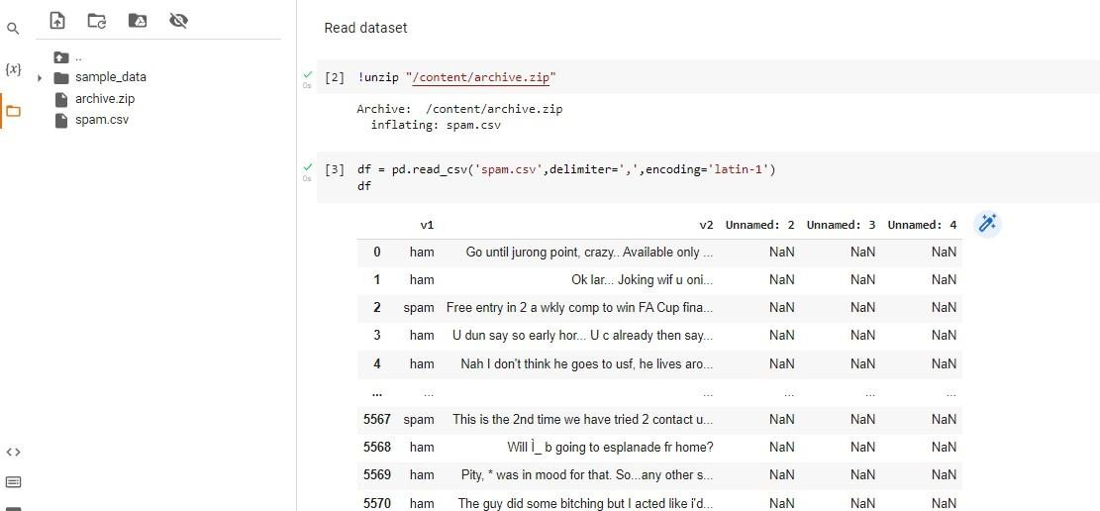

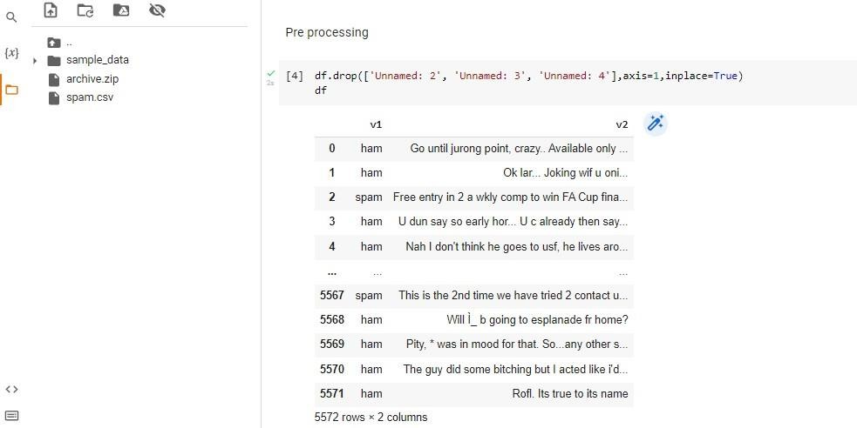

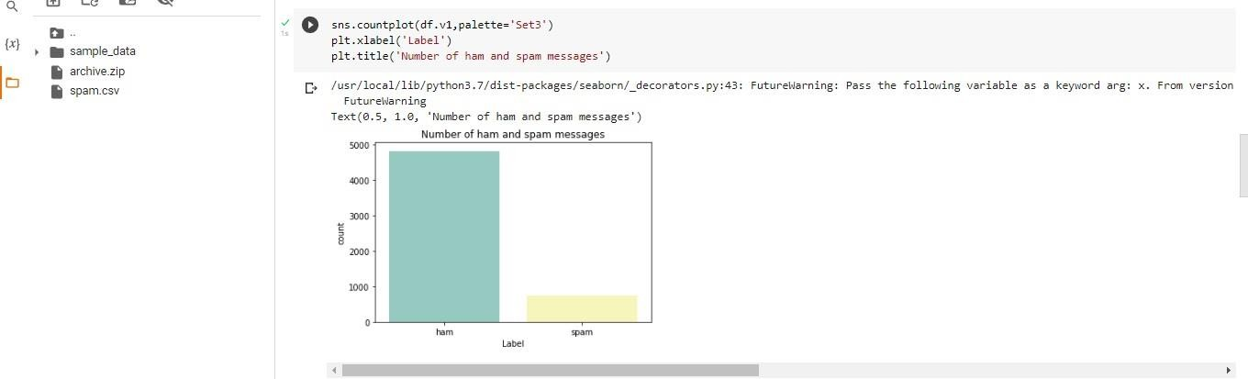

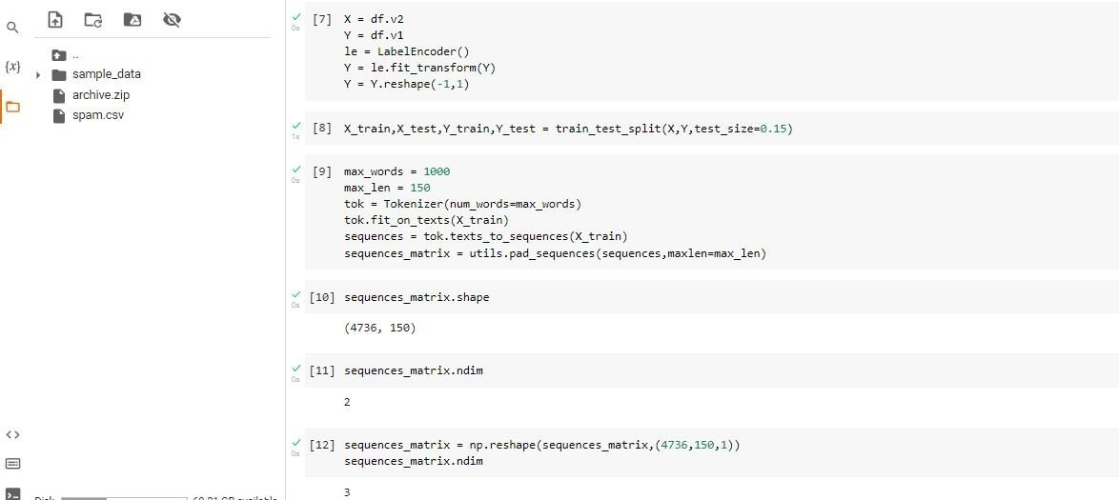

Question4:

Create modelSolution:

fromkeras.modelsimportSequentialfromkeras.layersimportDense

fromkeras.layersimportLSTM

fromkeras.layersimportEmbeddingmodel=Sequential()

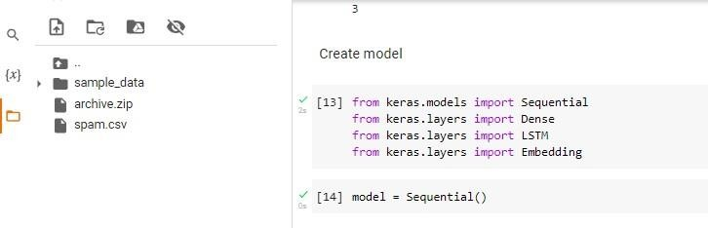

Question5:

Addlayers(LSTM,Dense-(Hiddenlayers),output)Solution:

model.add(Embedding(max_words,50,input_length=max_len))model.add(LSTM(units=64,input_shape = (sequences_matrix.shape[1],1),return_sequences=True))model.add(LSTM(units=64,return_sequences=True))model.add(LSTM(units=64,return_sequences=True))

model.add(LSTM(units=64))model.add(Dense(units = 256,activation = 'relu'))model.add(Dense(units=1,activation='sigmoid'))

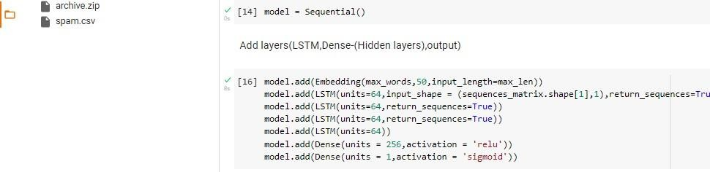

Question6:

CompilethemodelSolution:

model.summary()model.compile(loss='binary_crossentropy',optimizer='adam',metrics=['accuracy'])

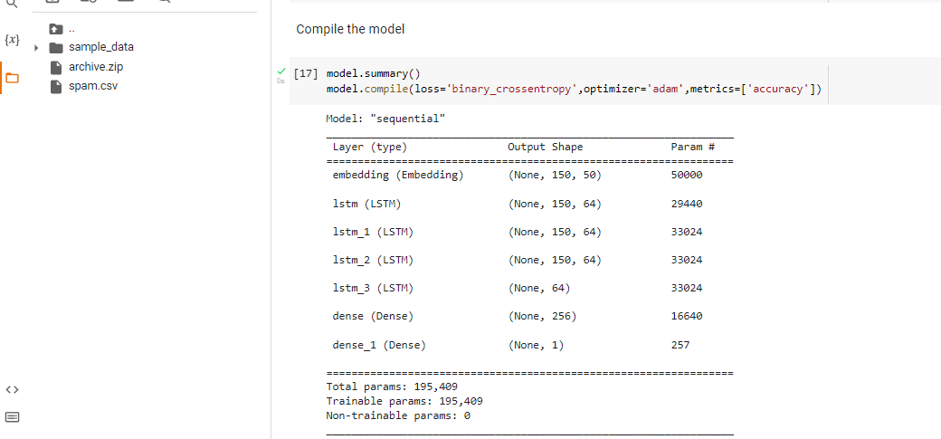

Question7:

FitthemodelSolution:

X=model.fit(sequences_matrix,Y_train,batch_size=128,epochs=5,validation_split=0.2)X

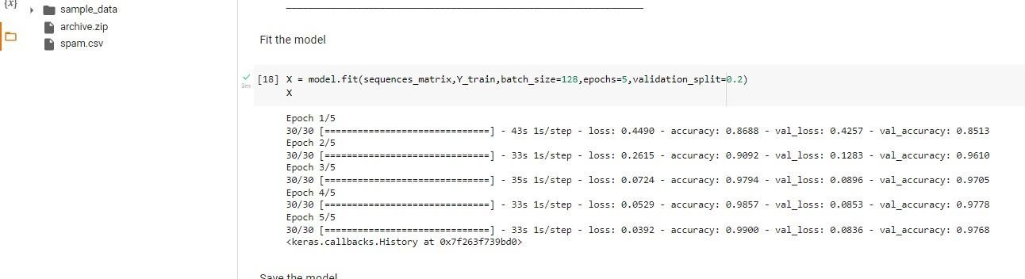

Question8:SavethemodelSolution:

model.save

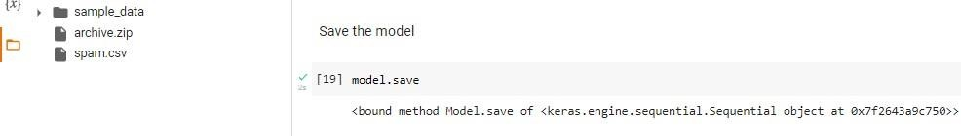

Question9:

TestthemodelSolution:

test_sequences=tok.texts_to_sequences(X_test)

test_sequences_matrix=utils.pad_sequences(test_sequences,maxlen=max_len)accr=model.evaluate(test_sequences_matrix,Y_test)

l=accr[0]a=accr[1]

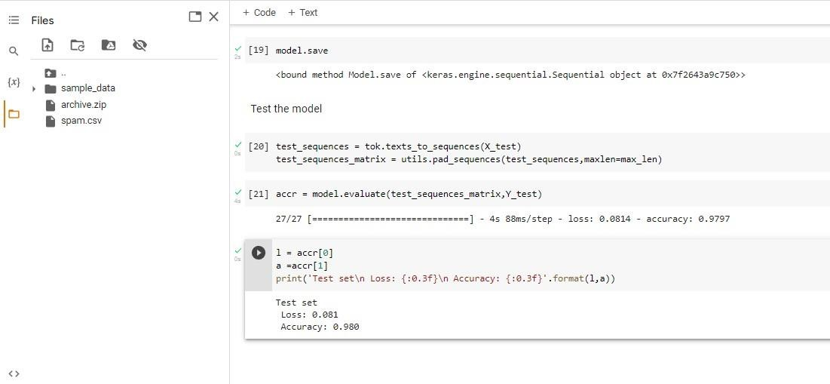print('Testset\nLoss:{:0.3f}\nAccuracy: {:0.3f}'.format(l,a))